CSP554—Big Data Technologies

Assignment #11

Worth: 5 points (1 point for each problem)

Exercises
Exercise 1)
Create an HBase table with the following characteristics
Table Name: csp554Tbl
First column family: cf1
Second column family: cf2
Then execute the DESCRIBE command on the table and return command you wrote and the output as the results of this exercise.
Command :
create 'csp554Tbl',{NAME => 'cf1'},{NAME => 'cf2'}
describe 'csp554Tbl'

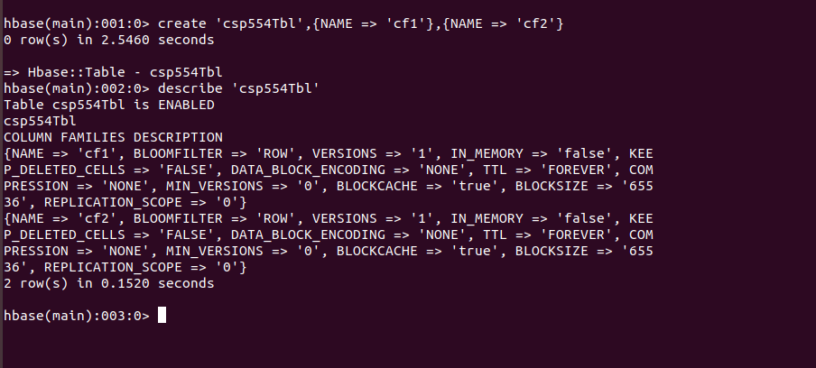
Exercise 2)
Put the following data into the table created in exercise 1:
Row Key | Column Family | Column (Qualifier) | Value
Row1 | cf1 | name | Sam
Row2 | cf1 | name | Ahmed
Row1 | cf2 | job | Pilot
Row2 | cf2 | job | Doctor
Row1 | cf2 | level | LZ3
Row2 | cf2 | level | AR7

Execute the SCAN command on this table returning all rows, column families and columns as the result of the exercise.
Command:
put 'csp554Tbl','Row1','cf1:Name','Sam'
put 'csp554Tbl','Row2','cf1:Name','Ahmed'
put 'csp554Tbl','Row1','cf2:job','Pilot'
put 'csp554Tbl','Row2','cf2:job','Doctor'
put 'csp554Tbl','Row1','cf2:level','LZ3'
put 'csp554Tbl','Row2','cf2:level','AR7'
scan 'csp554Tbl'
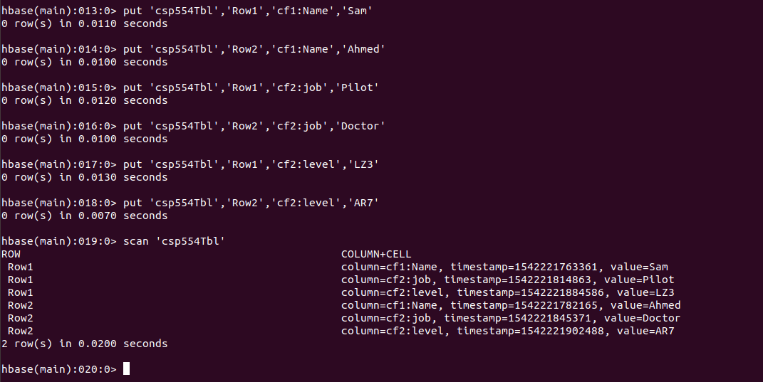
Exercise 3)
Using the above table write command that will get the value associated with row (Row1), column family (cf1) and column/qualifier (level). Provide the command and its result as the output of this exercise.
Command:
get 'csp554Tbl','Row1',{COLUMN => ['cf2:level']}
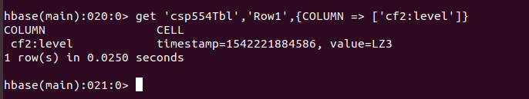

Exercise 4)
Using the above table write command that will get the value associated with row (Row2), column family (cf1) and column/qualifier (name). Provide the command and its result as the output of this exercise.
Command:
get 'csp554Tbl','Row2',{COLUMN => ['cf1:Name']}

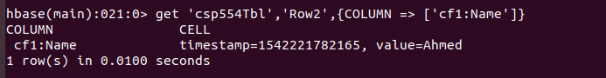
Exercise 5)
Using the above table write a SCAN command that will return information about only one row using the LIMIT modifier. Provide the command and its result as the output of this exercise.
Command:
scan 'csp554Tbl',{LIMIT => 1}
